Performance Management and Capacity Planning
Capacity planning is closely tied to performance management. Capacity planning determines the balance between your GroupWise 5.2 workload and its configuration at minimum cost, while meeting necessary user response time objectives. The goal of capacity planning is to find the best server and equipment to cost-effectively meet network workload demands and performance requirements. Capacity planning allows you to balance demand and supply—the demand for present and anticipated workload and the supply of present and future computer resources. A basic objective is consistent and acceptable user response times.
GroupWise performance depends on the number of users on the system, the operating environment of the server and workstations, and the bandwidth and speed that are available to the physical network. The type of server, NICs, and cabling systems play an important role in how the network operates under heavy traffic conditions.
In capacity planning, the planner must balance complex, vague, and sometimes confusing data about workload, user needs, and computer resources, devise a coherent plan, and make these needs known to others. Although capacity planning requires the use of statistical data and mathematical techniques, it also requires a planner with practical experience and expert-level knowledge of the computer industry. It is not an exact science.
Importance of Capacity Planning
Poor planning, whether it is over-estimating or under-estimating your computer resource needs, affects the corporate "bottom line." Planning for sufficient computer capacity is an ongoing process that allows you to avoid both overspending and insufficient capacity.
In the current drive to reduce corporate spending, allowance for the planning function is sometimes trimmed or even overlooked. However, reducing or neglecting this task risks a poorly planned GroupWise implementation with insufficient capacity. In this case, the GroupWise administrator spends a large amount of time, effort, and cost in fire drills—reacting to user and management complaints and creating short-term fixes rather than providing critical support, development, and strategic planning functions.
The amount of time, effort, and cost spent properly planning the GroupWise implementation will be worth the investment when the system adequately meets user response-time expectations and optimally utilizes system resources.

Subsystem Performance Comparison
This section offers guidelines for getting optimum performance/value from your Compaq server. These guidelines are based on tests designed by Compaq and Novell engineers. The tests are based on the analysis of the data gathered from Novell's in-house benchmark testing. This section describes each subsystem, presents the data collected from the test, and gives recommendations for the configuration of your Compaq server.
The subsystems to be discussed include:
- System Processor
- Memory
- Disk
System Processor
In a NetWare resource-sharing environment, network adapters, hard drive subsystems, and the amount of system memory are considered as more significant performance factors than the speed or type of system processor running in the server. However, for GroupWise, the system processor plays the most important role in performance tuning.
Pentium Pro vs. Pentium II. In the test, the performance of the Intel Pentium Pro processors was compared to Pentium II processors, the newest addition to Intel's line of sixth-generation microprocessors. The Pentium II processor is based on an Intel Pentium Pro processing core with the addition of faster core frequencies, a new form factor, a new cache structure, and multimedia extension(MMX) instruction.
As the test results in Figure 2 illustrate, the high core frequencies of the Pentium II processor enhance the performance of the Compaq system when used in a CPU-intensive environment.
Figure 2: Results of CPU performance tests.
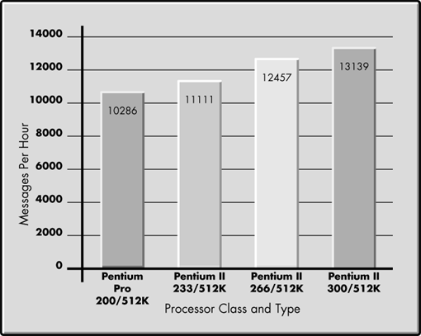
As these results show, 30 percent more messages can be delivered by the Pentium II processor at 300 MHz than by a Pentium Pro processor at 200 MHz. The high core frequencies can mean significant performance increase in a CPU-bound environment.
Level 2 Cache. Level 2 cache memory is the high-speed Static RAM that resides between the CPU and the main system memory. Level 2 cache stores snapshots of the most recently used system memory regions in fast static RAM memory, so it is available to the processor immediately. Since Level 2 cache memory returns information to the processor faster than system memory, the processor spends less time waiting for the main system memory to return data and more time doing real processing work. In the Pentium Pro processor, the L2 cache connects to the processor via a 64-bit data bus operating at the processor core frequency.
During the Level 2 cache test, the number of active users was held to 70 on a Compaq ProLiant 7000 system. The Level 2 cache configuration varied from 256KB through 1024KB (see Figure 3). The PL7000 was configured using a SMART-2/P disk array controller. A RAID 0 array of three striped drives was used as the NetWare volume.
Figure 3: Results of Level 2 cache performance tests.
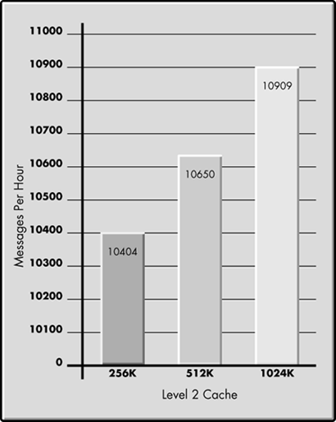
The data charted in Figure 3 show that upgrading a server Level 2 cache from 256KB to 1024KB increases the system level performance by 5%. When applications are executing, multiple system functions occur concurrently. With these functions occurring at the same time and each function able to benefit from Level 2 cache, the increased Level 2 cache gives each function more cache to utilize. This additional cache then increases the cache hit ratio and thereby increases overall performance and productivity. Cache performance can impact overall system performance, especially in multiprocessor configuration and in systems used in very memory-intensive application such as large database applications.
System Memory
The total amount of server memory has great impact on the overall performance of the system. The memory requirement for GroupWise 5.2 varies depending on many factors. Testing helps customers better understand the performance impact of adding memory. Keep in mind that providing more memory than is required can actually slow performance, because it means there is a larger pool of memory resources that the system and the processor must manage.
During the memory test, the number of active users was held to 70 on a Compaq ProLiant 3000 Pentium II 300 with 512K cache. Memory configuration varied from 64MB through 512MB (see Figure 4). The PL3000 was configured using a SMART-2/P disk array controller. The NetWare volume was on a RAID 0 array of three striped drives.
Figure 4: Results of memory performance test.
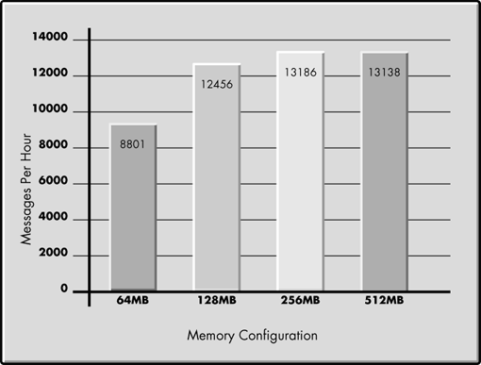
Note that performance improved 50 percent by doubling 64MB of memory to 128MB on the system. However, increasing memory beyond 128MB has minimal impact on performance. More memory is not necessarily always better; a system without a proper memory configuration may experience performance degradation.
Memory Recommendations. Compaq and Novell engineers have provided the memory recommendation shown in the table below. These guidelines can be used by the system administrator as a rule of thumb for determining initial GroupWise memory requirements. Once the system is in production, the administrator can use NetWare monitoring tools such as MONITOR.NLM to determine whether a memory upgrade is necessary. Also keep in mind that the memory configuration presented in the table below does not include memory for the NetWare operating system.
Concurrent Users | Actual Server Memory Used During Peak Time | Recommended Memory Configuration
100 Active Users  (100-250 Users) | 42 MB | 128 MB
250 Active Users  (250-500 Users) | 104 MB | 192 MB
500 Active Users  (500-1000 Users) | 116 MB | 256 MB
1000 Active Users  (1000-2500 Users) | 137 MB | 512 MB
Disk Subsystem
Key disk subsystem components can play a major part in overall system performance. Novell GroupWise is a very I/O-oriented application, so the disk subsystem is an important contributor to overall system performance. Identifying potential bottlenecks within your disk subsystem is crucial.
Determining disk subsystem impact involves analyzing these options:
- Fault Tolerance (RAID 0, RAID 1, RAID 4, RAID 5)
- Accelerator Read/Write Ratio of the Array Controller
- Cache Memory
- Volume Block Size
Fault Tolerance. Redundant Array of Inexpensive Disks (RAID) levels are briefly defined below.
RAID 0 - No Fault Tolerance
RAID 0 is not true fault tolerance because it does not provide data redundancy, and thus provides no fault protection against data loss. If a logical drive fails, data on that drive will be lost. No logical drive capacity is used for redundant data. RAID 0 is known as "stripe sets" because data is simply striped across all of the drives in the array. This configuration provides high performance at a low cost. However, you incur a risk of possible data loss.
RAID 1 - Drive Mirroring
This is typically the highest performance method of fault tolerance. RAID 1 is the only possible option for fault tolerance if no more than two drives are selected. This configuration of mirrored sets of data uses 50 percent of drive storage capacity to provide greater data reliability by storing a duplicate of all user data on a separate disk drive. Therefore, half of the drives in the array are duplicated or "mirrored" by the other half. This RAID level does provide performance equal to or better than RAID 0, but your drive cost doubles because this level requires twice as many disk drives to store the same amount of data. Therefore, it might not be cost-effective for your environment.
RAID 4 - Data Guarding
RAID 4 is referred to as "data guarding" because it uses parity data to guard against the loss of data. While this is similar to RAID 5 ("distributed data guarding"), the difference is that RAID 4 writes all of the parity data to a dedicated single drive in the array. If a drive fails, the parity data and the remaining functioning drives with data use the parity information to reconstruct data from the failed drive. But if the drive(s) containing parity information fail, parity drive data cannot be reconstructed.
Space required for parity is on a single drive. For example, if you have a three-drive system, then 33 percent of the total drive space (one drive) would be used for fault tolerance. In this case, two drives would store data, and one drive would store parity data. A maximum of 14 drives can be supported. Of these 14 drives, 7 percent of the total space available or one drive would be used for parity data. Writing all the parity data to a single drive also introduces performance degradation, since parity data is not striped across all drives. Therefore, a disk configuration using RAID 4 for fault tolerance has historically proven to yield performance results at a level below RAID 5 configurations.
RAID 5 - Distributed Data Guarding
RAID 5 is commonly called "distributed data guarding" or "stripe sets with parity." This level of RAID divides data into blocks, calculates parity, then writes the data blocks in "stripes" to the disk drives, saving one stripe on each drive for the parity data. This method is cost-effective, with the added benefit of high performance because the parity information is distributed across all the drives. Total disk space used for redundancy is equivalent to the capacity of a single drive. Therefore, the overall cost for this method of fault tolerance is lower than for Disk Mirroring (RAID 1).
Fault Tolerance Test Results
The Compaq SMART-2 Array Controller provides high availability, high performance, and fault tolerance for data stored on hard disks. It also provides significant expansion capabilities for large-scale centralized computing, protecting mission-critical data where it has previously been cost prohibitive.
The tests compare the fault tolerance levels of RAID 0, RAID 1, RAID 4, and RAID 5 (see Figure 5). The tests were run on a Compaq ProLiant 6500 with a single Pentium Pro 200 processor and 512MB of RAM. The test had 70 active users. The RAID 0 and RAID 5 tests were performed using three 2.1GB drives in an array. The RAID 1 test was run using six total drives, with three drives mirroring the other three.
Figure 5: Results of fault tolerance tests.
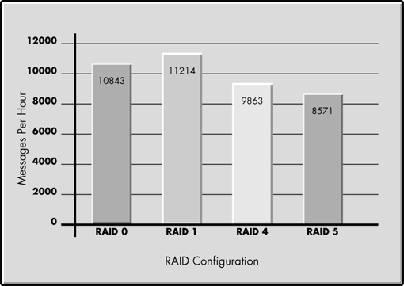
These results show that RAID 1 performed best, outperforming RAID 0 by 5 percent and performing about 30 percent better than RAID 5. Keep in mind that although RAID 0 does utilize available disk space most efficiently, this level provides no protection against data loss. You risk data loss if you choose RAID 0. For systems with critical data, RAID 5 is frequently the best choice because it provides better disk space usage.
Based on these tests, the recommendation for a GroupWise system would be RAID 1 because of the performance gains over RAID 5 combined with hardware fault tolerance.
Array Controller Accelerator Read/Write Ratio. The Compaq Array Controller Configuration Utility offers five options for Read/Write ratio:
- 0/100
- 25/75
- 50/50
- 75/25
- 100/0
During the Read/Write Ratio test, the number of active users was held to 70 on a Compaq ProLiant 3000 Pentium II 300 system with 512KB cache. The Read/Write Ratio was configured at 25/75, 50/50, and 75/25 (see Figure 6). The PL3000 was configured using a SMART-2/P disk array controller. A RAID 0 array of three striped drives was used as the NetWare volume.
Figure 6: Results of read/write ration comparison test.
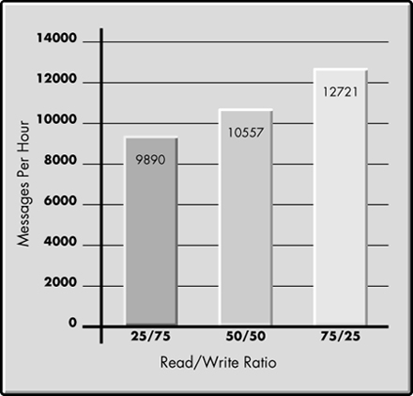
These test results show the Read/Write Ratio of 75/25 achieved best performance, outperforming the other two configurations by 20 to 30 percent. This indicates an optimal Read/Write Ratio of 75/25 for GroupWise because of performance improvement.
Cache Memory. The enhanced Array Accelerator on the SMART-2 Controller has 4 MB of usable cache to offer good performance with optimal cost effectiveness. The enhanced Array Accelerator on the SMART-2/DH Controller has 16 MB of usable cache. With the streamlined architecture of the SMART-2 Controller, these cache sizes provide excellent performance enhancements for sequential, small read requests and small- to medium write requests (see Figure 7).
Figure 7: Results of cache size comparison test.
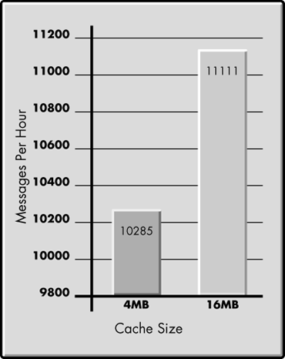
These results quantified a 7-10 percent performance gain for GroupWise mail activity when upgrading Array Accelerator cache memory from 4MB to 16MB. Therefore, optimizing cache size provides great performance enhancement.
To gain added performance for a GroupWise system, consider using the SMART-2/P Controller with the cache memory upgraded from 4 MB to 16 MB. Upgrading the cache requires replacing the cache board on the SMART-2/P controller with a 16-MB cache board, so customers can maintain their previous hardware investment.
Volume Block Size. One feature of the NetWare operating system is its ability to support large volume blocks. Using a large volume block size increases the performance of almost every associated subsystem, such as disk channel, file cache, directory cache, directory entry table, and file allocation table. This large volume block size does not waste disk capacity when storing lots of small files because of how files are suballocated.
The results shown in Figure 8 display a noticeable improvement in message rates when the volume block size is set to 64KB.
Figure 8: Results of volume block size comparison test.
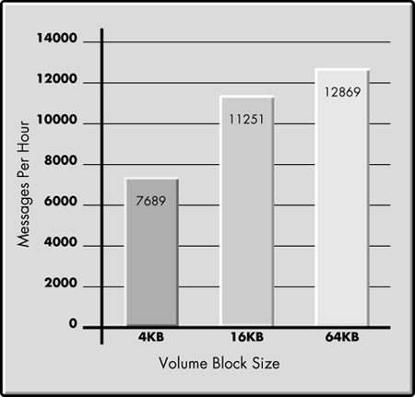
Compaq and Novell engineers recommend that you always select a volume block size of 64KB because the smaller the block size, the more system memory is consumed to manage the blocks. With the suballocation feature provided in intraNetWare, a block size of 64KB will give you the best performance of file reads and writes without wasting disk space.

